MILESTONE 2
Faculty Information Storage System
ERD Design & Normalization
Subject | Database Systems
Instructor | Ali Hassan
Group Members | Muhammad Gulsher, Muhammad AliBilal
Semester | BSSE-A
Submission Date | April 26, 2025
Milestone | Milestone 2 — ERD Design & Normalization

SECTION 1 — Overview
Milestone 2 formally applies the database normalization process to the schema established in Milestone 1. Every table is reviewed step by step through First Normal Form (1NF), Second Normal Form (2NF), and Third Normal Form (3NF). All findings are documented with clear written justification — whether or not a change was needed. Any redundancies or structural issues discovered have been resolved and reflected in the updated schema.

SECTION 2 — Normalization Process Overview
Normalization is the process of organizing a relational database to reduce data redundancy and improve data integrity. The three normal forms applied in this milestone are defined below:

- 1NF (First Normal Form) — All attributes must be atomic (single-valued). No repeating groups. Each row must be uniquely identifiable by a primary key.
- 2NF (Second Normal Form) — The table must already be in 1NF. Every non-key attribute must be fully functionally dependent on the entire primary key. No partial dependencies are allowed.
- 3NF (Third Normal Form) — The table must already be in 2NF. No non-key attribute should be transitively dependent on the primary key through another non-key attribute.

Note: All tables in this schema use single-column surrogate primary keys (INT AUTO_INCREMENT). This design eliminates the possibility of partial dependencies by default, making 2NF straightforward to verify across all tables.

SECTION 3 — Table-by-Table Normalization Analysis

3.1 faculty Table
Attributes: faculty_id, name, email, phone, cnic, gender, date_of_birth, created_at

First Normal Form (1NF)
Result: PASS
All attributes are atomic and single-valued. The name column stores one full name, email stores one address, cnic stores one national ID, and gender uses a restricted ENUM. No repeating groups or multi-valued fields exist. Each faculty member is uniquely identified by the surrogate primary key faculty_id.

Second Normal Form (2NF)
Result: PASS
The table uses a single-column primary key (faculty_id). A single-column PK makes partial dependency mathematically impossible — every non-key attribute can only depend on the whole key. All attributes fully describe the faculty member identified by faculty_id.

Third Normal Form (3NF)
Result: PASS
No transitive dependencies exist. Each non-key attribute describes the faculty member directly through faculty_id. There is no dependency chain of the form faculty_id to X to Y for any pair of non-key attributes.

Changes Made
No structural changes were required.

Justification
The faculty table was designed correctly from the start. All attributes are direct, atomic properties of a faculty member with no redundancy or dependency violations at any normal form level.

3.2 department Table
Attributes: dept_id, dept_name, hod_name, faculty_count

First Normal Form (1NF)
Result: PASS
All attributes are atomic. dept_name stores a single department name, hod_name stores a single person name, and faculty_count stores a single integer. No multi-valued attributes or repeating groups are present. Each department is uniquely identified by dept_id.

Second Normal Form (2NF)
Result: PASS
Single-column primary key (dept_id) makes partial dependency impossible. All non-key attributes — dept_name, hod_name, and faculty_count — are fully dependent on dept_id only.

Third Normal Form (3NF)
Result: FAIL / FIXED
3NF violation detected. The attribute faculty_count is a derived value — it can be computed at any time by counting rows in the faculty table that belong to this department. Storing it here creates an update anomaly: if a faculty record is added or deleted and faculty_count is not manually updated, the stored value becomes inconsistent with the actual data.

Changes Made
faculty_count has been removed from the department table.

Problem Identified
The count is directly derivable from the faculty table. Storing it here means any INSERT or DELETE on faculty requires a manual update to this field — a classic update anomaly.

Replacement Query
SELECT dept_id, COUNT(*) AS total_faculty FROM faculty GROUP BY dept_id;

Justification
faculty_count is a redundant, derived attribute. Storing computed values introduces update anomalies — the count can become stale whenever faculty records change. The correct approach is to retrieve this value dynamically using an aggregate SQL query.

3.3 qualifications Table
Attributes: qual_id, faculty_id, degree, institution, year_completed

First Normal Form (1NF)
Result: PASS
All attributes are atomic. Each row stores exactly one degree, one institution, and one year. A faculty member with multiple qualifications is represented using multiple rows — not multiple columns or comma-separated values. This is the correct 1NF approach.

Second Normal Form (2NF)
Result: PASS
Single-column primary key (qual_id). All non-key attributes fully depend on qual_id. faculty_id is a foreign key reference, not a partial dependency. No composite key concerns exist.

Third Normal Form (3NF)
Result: PASS
No transitive dependencies exist. degree, institution, and year_completed all directly describe the specific qualification record identified by qual_id. faculty_id is a proper relational foreign key reference and does not create a transitive dependency.

Changes Made
No structural changes were required.

Justification
The qualifications table correctly stores one qualification per row using a separate table with a foreign key to faculty. By isolating qualifications into their own rows, the design satisfies all three normal forms without modification.

3.4 workload Table
Attributes: workload_id, faculty_id, course_name, credit_hours, semester

First Normal Form (1NF)
Result: PASS
All attributes are atomic. Each row stores exactly one course assignment for one faculty member in one semester. If a faculty member teaches three courses, three separate rows are created. No multi-valued attributes exist.

Second Normal Form (2NF)
Result: PASS
Single-column primary key (workload_id). All non-key attributes — faculty_id, course_name, credit_hours, semester — fully depend on workload_id. faculty_id is a foreign key reference and does not create partial dependency.

Third Normal Form (3NF)
Result: PASS
No transitive dependencies exist. course_name, credit_hours, and semester all directly describe the workload record identified by workload_id. No non-key attribute determines another non-key attribute.

Changes Made
No structural changes were required.

Justification
The workload table correctly separates course assignments into individual rows. Each attribute describes the specific assignment record directly. The table satisfies all three normal forms without modification.

3.5 users Table
Attributes: user_id, username, password, role, faculty_id, last_login

First Normal Form (1NF)
Result: PASS
All attributes are atomic and single-valued. username stores one login name, password stores one hashed string, role uses a restricted ENUM, and last_login stores one timestamp. No repeating groups exist. Each user account is uniquely identified by user_id.

Second Normal Form (2NF)
Result: PASS
Single-column primary key (user_id). All non-key attributes — username, password, role, faculty_id, last_login — fully depend on user_id. There are no composite keys and no partial dependencies.

Third Normal Form (3NF)
Result: PASS
No transitive dependencies exist. username, password, role, and last_login all directly describe the user account identified by user_id. faculty_id is a nullable foreign key — a proper relational reference, not a transitive dependency. role does not determine any other stored attribute.

Changes Made
No structural changes were required.

Justification
The users table correctly separates authentication data from faculty profile data. By using faculty_id as an optional foreign key, the table maintains a clean link to the faculty table without duplicating any faculty information. All three normal forms are satisfied without modification.

SECTION 4 — Summary of Changes & Redundancy Removed

After reviewing all five tables through the full normalization process, one structural change was identified and applied:

Change # | Attribute Removed | Reason | Resolution
1 | department.faculty_count | Derived/computed value. Becomes stale if not updated when faculty records change. Introduces update anomaly risk. | Removed from schema. Retrieved dynamically: SELECT dept_id, COUNT(*) FROM faculty GROUP BY dept_id;

All other tables (faculty, qualifications, workload, users) passed all three normal forms without any structural modification.

SECTION 5 — Updated ERD (Milestone 2)

The Entity-Relationship Diagram below reflects the normalized schema after Milestone 2. The faculty_count attribute has been removed from the department table. All primary keys, foreign keys, relationships, and cardinalities are shown.

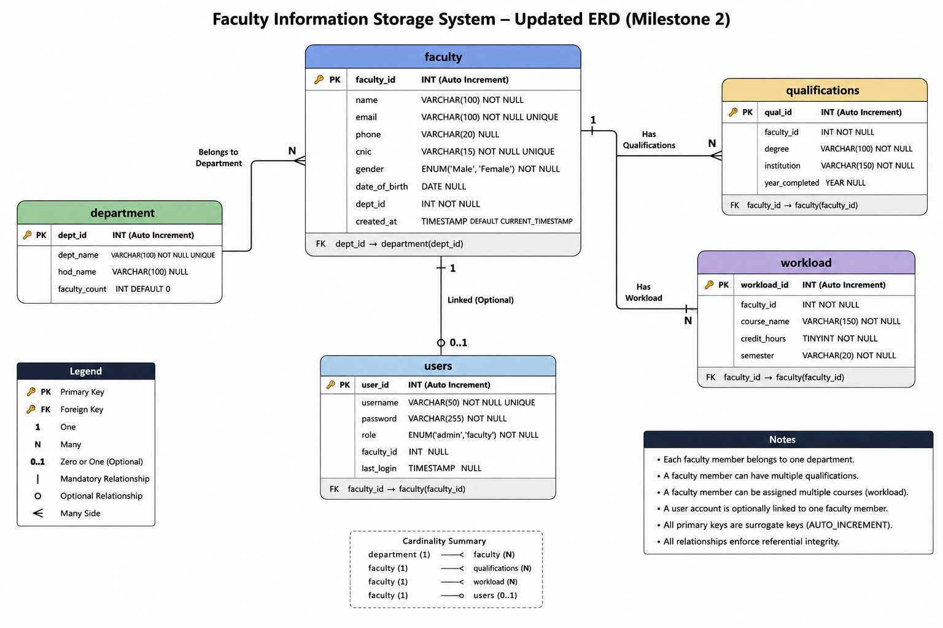
Figure 1 — Updated Entity-Relationship Diagram, Faculty Information Storage System (Milestone 2)

ERD Update Summary:
- department table: faculty_count attribute removed after 3NF analysis.
- All primary key relationships verified and confirmed across all 5 tables.
- All foreign key relationships verified: qualifications.faculty_id, workload.faculty_id, users.faculty_id, faculty.dept_id all reference correct parent tables.
- Relationship cardinalities confirmed: department(1) to faculty(N), faculty(1) to qualifications(N), faculty(1) to workload(N), faculty(1) to users(0..1).

SECTION 6 — Final Normalized Schema

The following tables represent the finalized schema after applying 1NF, 2NF, and 3NF normalization.

6.1 faculty
Attribute | Data Type | Constraint | Description
faculty_id | INT | PK, AUTO_INCREMENT | Unique faculty identifier
name | VARCHAR(100) | NOT NULL | Full name of faculty member
email | VARCHAR(100) | NOT NULL, UNIQUE | Official email address
phone | VARCHAR(20) | NULL | Contact phone number
cnic | VARCHAR(15) | NOT NULL, UNIQUE | National ID number
gender | ENUM('Male','Female') | NOT NULL | Gender of faculty member
date_of_birth | DATE | NULL | Date of birth
created_at | TIMESTAMP | DEFAULT NOW() | Record creation timestamp

6.2 department (faculty_count removed)
Attribute | Data Type | Constraint | Description
dept_id | INT | PK, AUTO_INCREMENT | Unique department identifier
dept_name | VARCHAR(100) | NOT NULL, UNIQUE | Name of the department
hod_name | VARCHAR(100) | NULL | Head of Department name

6.3 qualifications
Attribute | Data Type | Constraint | Description
qual_id | INT | PK, AUTO_INCREMENT | Unique qualification ID
faculty_id | INT | FK -> faculty(faculty_id) | Associated faculty member
degree | VARCHAR(100) | NOT NULL | Degree title (e.g., PhD, MSc)
institution | VARCHAR(150) | NOT NULL | Name of awarding institution
year_completed | YEAR | NULL | Year of completion

6.4 workload
Attribute | Data Type | Constraint | Description
workload_id | INT | PK, AUTO_INCREMENT | Unique workload record ID
faculty_id | INT | FK -> faculty(faculty_id) | Assigned faculty member
course_name | VARCHAR(150) | NOT NULL | Name of the course
credit_hours | TINYINT | NOT NULL | Credit hours for the course
semester | VARCHAR(20) | NOT NULL | Semester (e.g., Fall 2025)

6.5 users
Attribute | Data Type | Constraint | Description
user_id | INT | PK, AUTO_INCREMENT | Unique user identifier
username | VARCHAR(50) | NOT NULL, UNIQUE | Login username
password | VARCHAR(255) | NOT NULL | Hashed password
role | ENUM('admin','faculty') | NOT NULL | System access role
faculty_id | INT | FK -> faculty(faculty_id), NULL | Linked faculty record (if any)
last_login | TIMESTAMP | NULL | Last login timestamp

SECTION 7 — Conclusion
The Faculty Information Storage System schema has been formally reviewed and normalized up to Third Normal Form (3NF). The analysis confirmed that the original schema was well-designed overall, with one clear improvement identified during the process.

The faculty_count attribute in the department table was removed because it represents a computed, derived value. Storing it directly creates a risk of inconsistency — any time a faculty record is inserted or deleted, the count would need to be manually updated, which is error-prone. The correct approach is to derive this value dynamically through an SQL aggregate query.

All four remaining tables — faculty, qualifications, workload, and users — passed all three normal forms without requiring any structural changes. The justifications provided for each table confirm this is not a case of simply stating compliance without reasoning — each table was analyzed attribute by attribute.

The final normalized schema and updated ERD provide a clean, consistent, and anomaly-free foundation for the next milestones: dataset preprocessing (Milestone 3), DDL implementation (Milestone 4), and database population (Milestone 5).

SECTION 8 — GitHub Commit Message

Recommended commit message for this milestone:

M2: Applied 1NF, 2NF, and 3NF normalization; removed redundant faculty_count from department; updated ERD and schema

Faculty Information Storage System · Milestone 2 · Muhammad Ali Bilal & Muhammad Gulsher · BSSE-A

